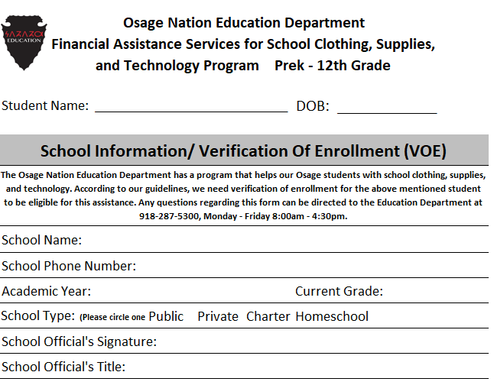

**Please return completed VOE to:**

[schoolassistance@osagenation-nsn.gov](mailto:schoolassistance@osagenation-nsn.gov)

**OR**

Osage Nation Education Department Attn: School Assistance

102 Buffalo Ave

P.O. Box 250

Hominy, OK 74035