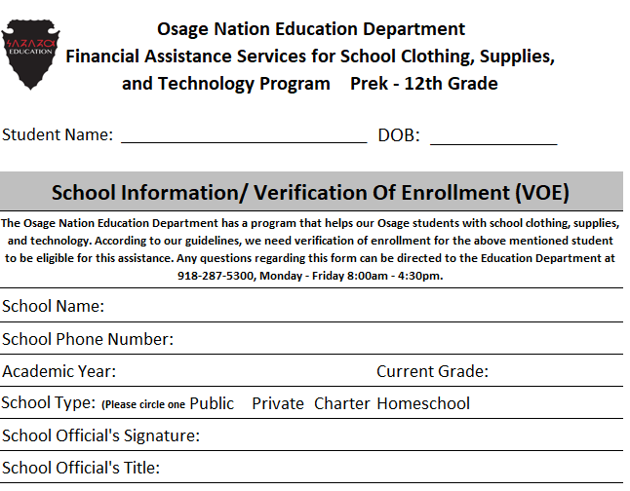
Please return completed VOE to:
schoolassistance@osagenation-nsn.gov
OR
Osage Nation Education Department Attn: School Assistance
102 Buffalo Ave
P.O. Box 250
Hominy, OK 74035

